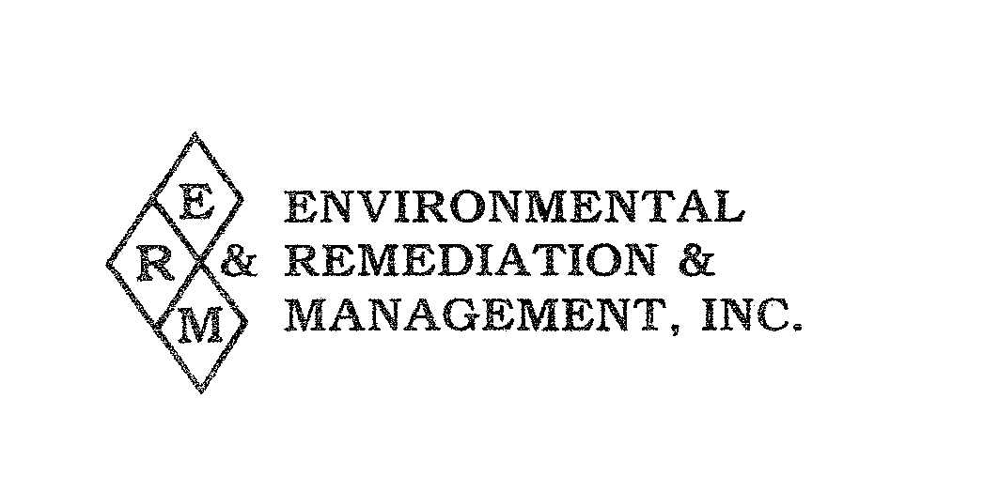
August 26, 2017

To Parent Teacher & Employee Organizations:

The East Rutherford Board of Education has contracted with Environmental Remediation & Management Inc. to act as their “Designated Person” as defined under the Asbestos Hazard Emergency Response Act (AHERA) of 1986. AHERA required that all educational facilities be inspected for asbestos – containing materials and develop a remedial plan of action on or before May 9, 1989. In addition, each educational facility shall reassess all identified asbestos – containing materials or materials assumed to be asbestos, at least once every six months (periodic surveillance) and re-inspect those facilities every three years.

The East Rutherford Board of Education is in compliance with these requirements. The next inspection is scheduled for October, 2017, and will be a Tri-annual re-inspection. “Periodic Surveillance inspections are performed every six months, unless a Tri-Annual re-inspection is performed in that month. The next “periodic surveillance” inspection will be performed in April of 2018.

Following each inspection, appropriate remedial actions are recommended to the Board of Education by an accredited Asbestos Management Planner. The remedial plans of action and recommended schedules for implementation (Asbestos Management Plans) are available for review at the East Rutherford Administrative Office, as well as in each school office.

This past year an asbestos abatement effort was undertaken at the A.S. Faust School. The project involved the removal of pipe insulation from the Kitchen/Pool storage room and was performed in accordance with all applicable State and Federal rules and regulations. The complete details of this project can be viewed within the Asbestos Management Plan.

We will continue to keep you informed of our AHERA compliance.

Respectfully Yours,

Cathy DiNardo

Cathy DiNardo
Designated Person on behalf
of the East Rutherford Board of Education

