The ERSD Parent Academy Presents:

Supporting Language & Literacy Development During Remote Learning (Grades 1-8)

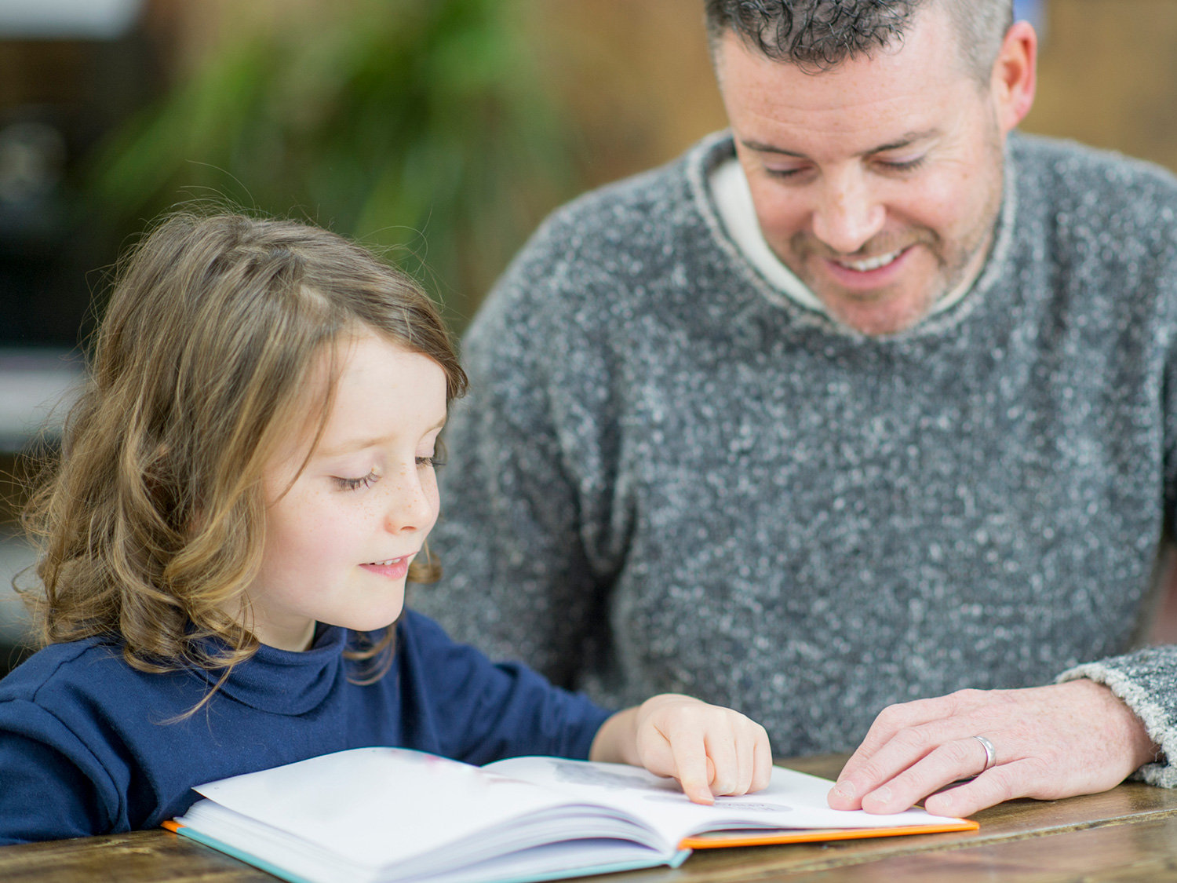

Do you have concerns about your child’s language skills? Are you worried that your child is falling behind during the pandemic? Join the district therapists as we discuss strategies for promoting language, reading, and writing skills during this difficult time.

**Presenters**: Alison Bono, M.S., CCC-SLP, Bracha Waldman, M.S., CCC-SLP, Amanda Rusin, OTR/L, District Speech & Language Pathologists and Occupational Therapist

**Date & Time:** Tuesday, March 30th, 7:00pm

**Location**: Zoom

<https://us02web.zoom.us/j/87593129284?pwd=RjVXT21adWZHdG03SFU2aXdybjdhdz09>

**Meeting ID**: 875 9312 9284

**Password**: 348462